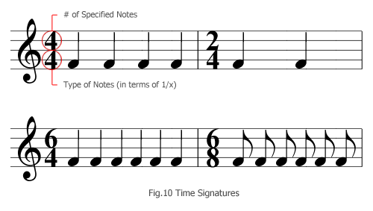
Equation to determine the value of dotted notes:
1/4 + ½(1/4) = 3/8
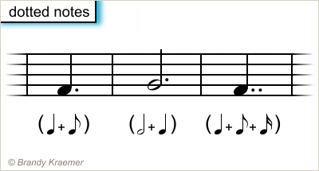
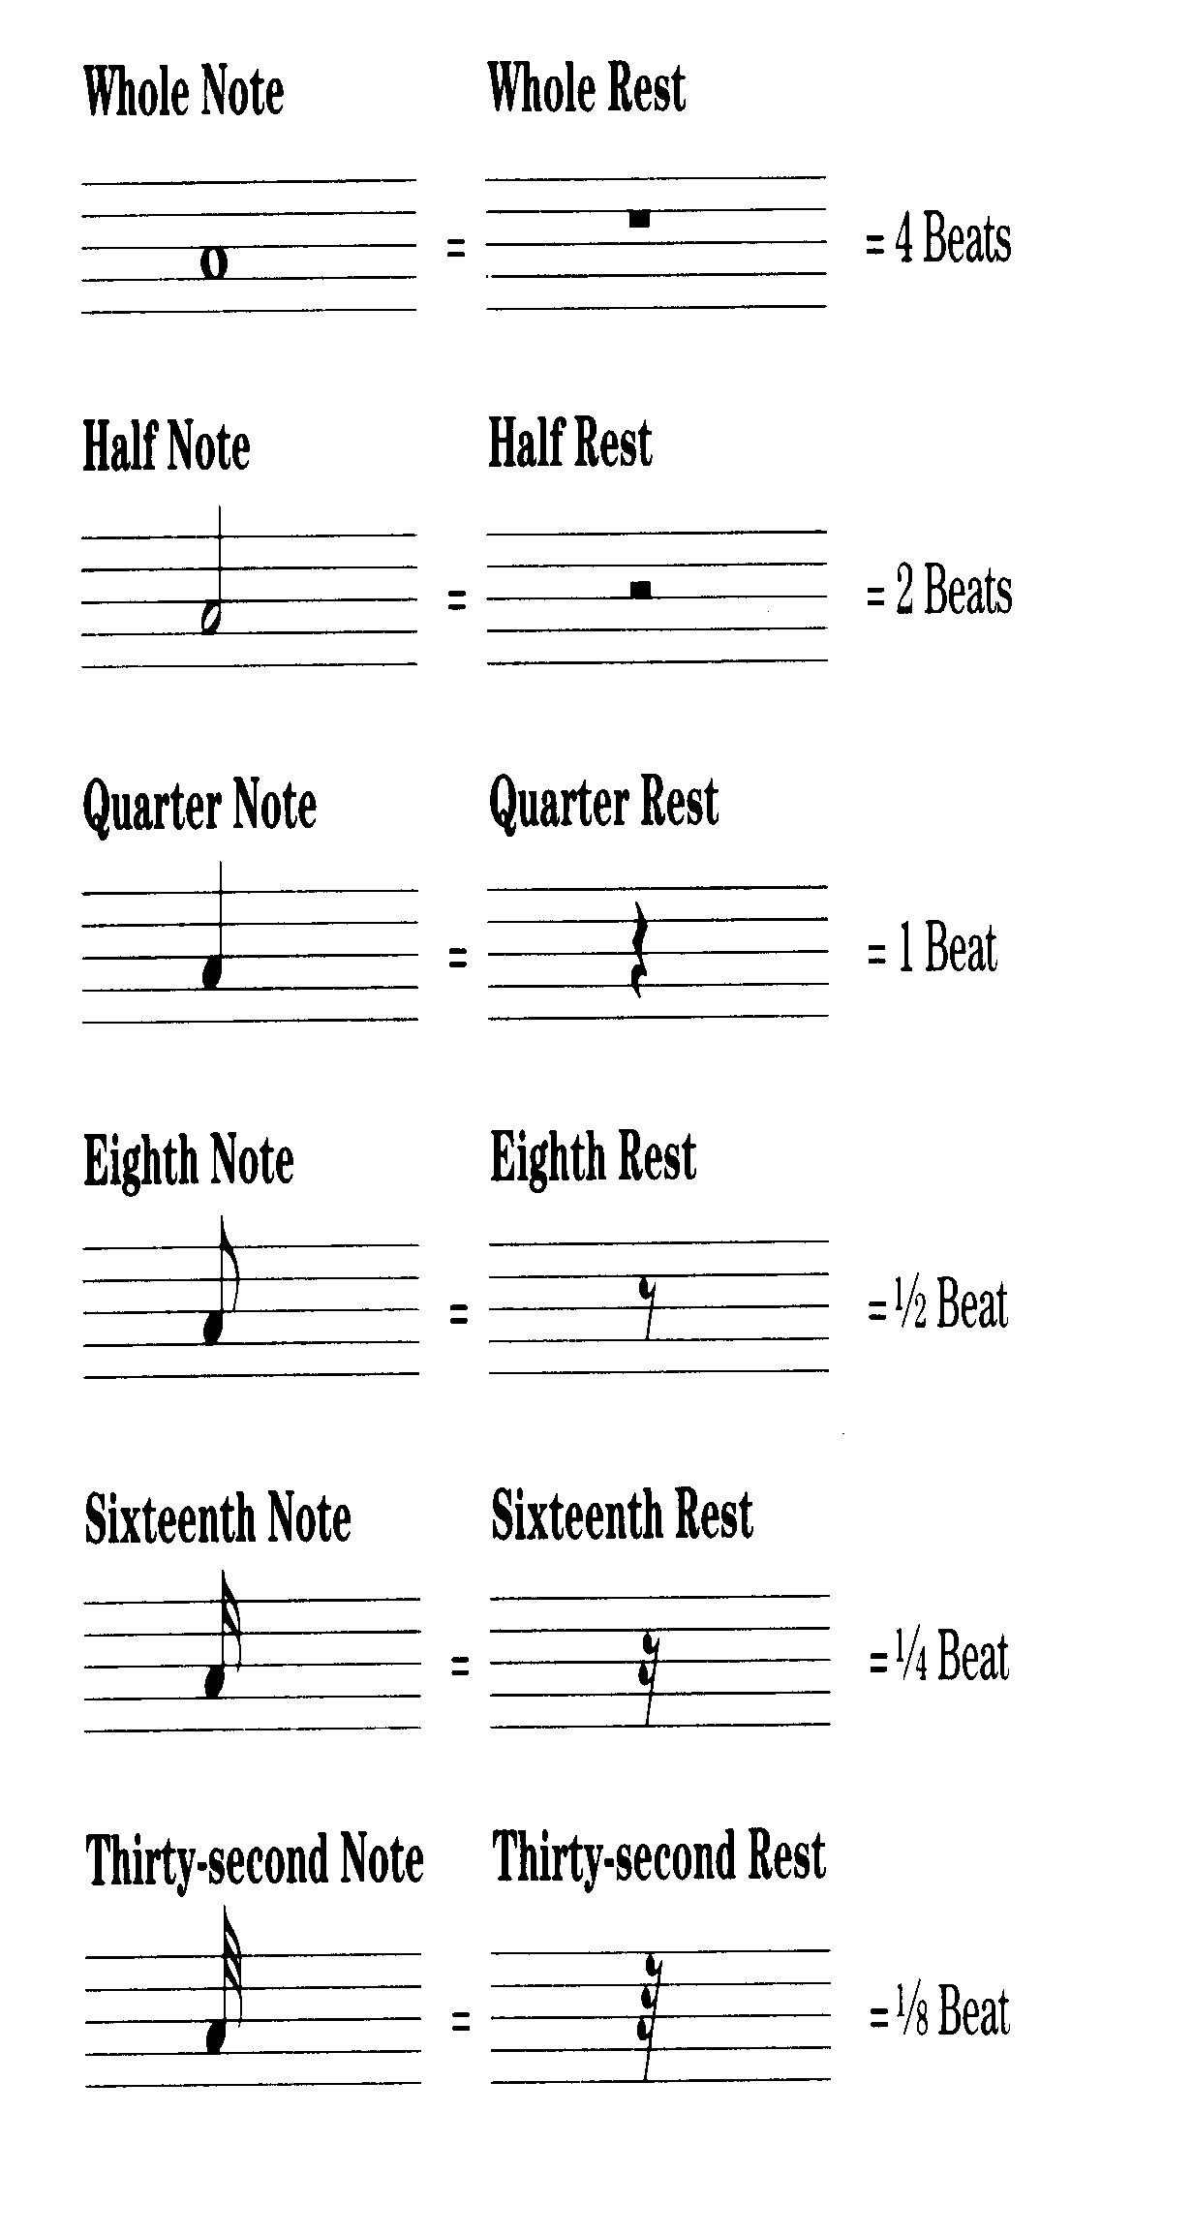
One quarter note plus half of itself equals the value of 3 eighth notes.

